How to Run a Security Testing - ZAP HUD
Summary
OSSA Security Testing is a required task for OSSA compliance.
To begin the testing, you need to download and install OWASP Zed Attack Proxy Heads-Up Display (ZAP HUD) project (https://www.zaproxy.org/download/). For installation instruction, see attachments of this article for the instruction file.

- Open NetSuite Website, preferably sandbox
- Start ZAP HUD.
- Click "Manual explore".
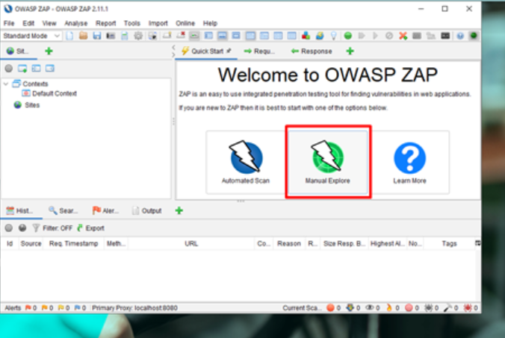
- Input URL of your client's website to secure test, then click "Launch Browser". **Watch out for 504 Gateway error.
Note: If an error occurred, same as below, this is a ZAP error when running on Windows. Please go to step-by-step troubleshoot below:
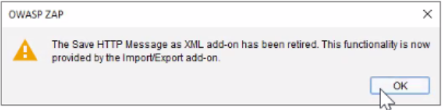

- Go to upper left part of the app and click the "Out of scope" button.
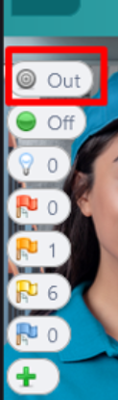
- Double click HUD Context then click "2. include in Context" and click "Modify" to edit and remove the wild card or "*" on the end of the URL.
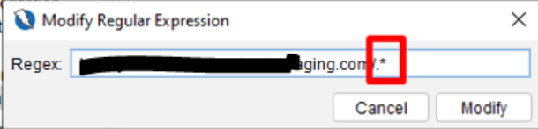

- Go to right part of the app, find the cross-hair logo then click "Attack mode". Attack mode will turn on.
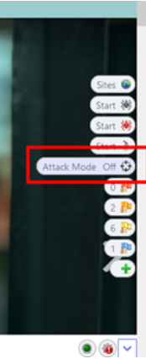

- Start the scanning by clicking "Active Scan Start" button. The button is right above the attack mode button. Wait until it is finished.
** Note: Don't close the browser so the scan process will be still active while you can work on other work. This scan may take a while. You can check the progress of the scan by hovering the mouse pointer on the active scan button**
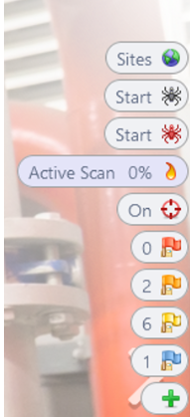

- Once done the vulnerability will show up. You can click the flags to view the findings.
- Findings consist of: High -- Medium -- Low
  - ** If critical or high came up, you should save it and report it to "Bjorn's team"**
  - **Temporary process is you should upload the vulnerability findings in Oradocs. Kerrie Ulrich(CSL) must be added**
- Complete CRM tasks, where you will mark at which time it ran and you have to add the report.
- Click "plus (+)" button to record findings/generate report.
Extract to PDF or HTML instructions
Recording of first test: Security Testing - Zap Installation
Note: Recording session is not finalized, it is being edited to only contain how to run Zap Hud.

Limiting scan scope to prevent long-running active scans:
- Set up a manual scan with HUD enabled in OWASP ZAP as described in the steps above (follow only up to step 4 of the previous section)

- Perform authentication if necessary and navigate to the specific directory/page to restrict the scan
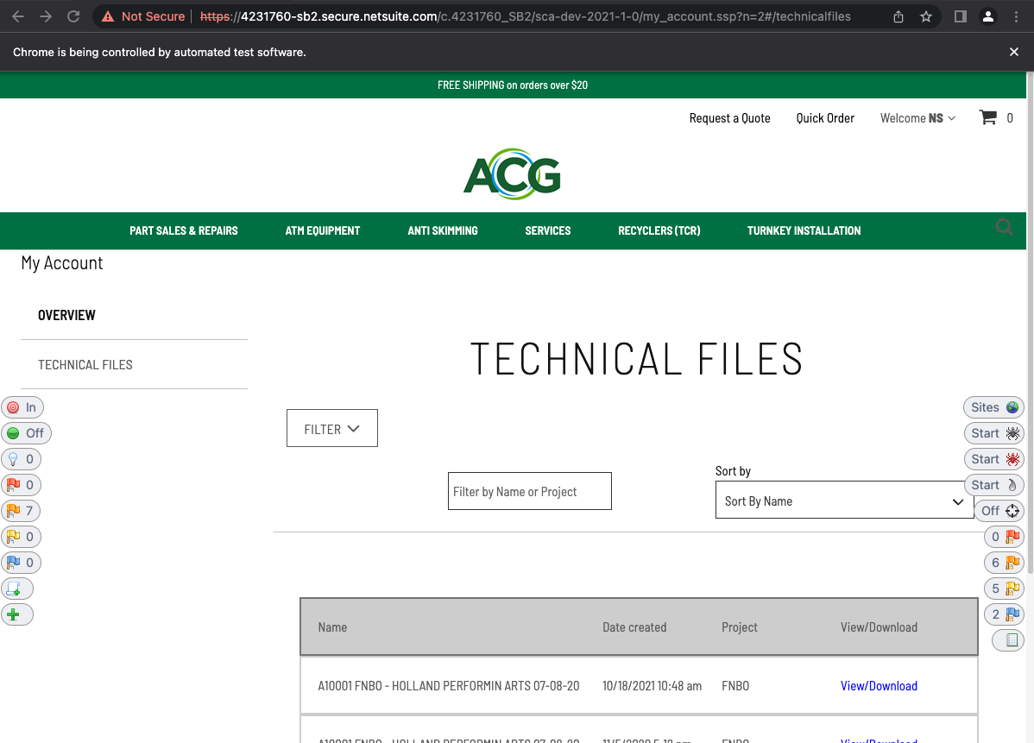

- Click on the Add to Scope button (topmost-lefthand side) of ZAP HUD and add the scope to domain

- Double click on HUD Context in the Contexts Section in the main OWASP ZAP window

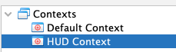

- In the Session Properties Windows, navigate to 2: Include in Context under the 2: HUD Context section

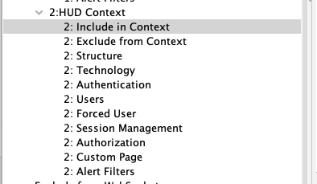

- Highlight the default regular expression and click on Modify

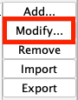

- Change the regular expression* to one that restricts the scan to the desired directory/file; make sure that all special characters that are part of the URL are escaped with a backslash (\)

Examples:

- Restrict to my_account.ssp and all its elements

Target URL:
https://4231760-sb2.secure.netsuite.com/c.4231760_SB2/sca-dev-2021-1-0/my_account.ssp?n=2#/technicalfiles

Regular Expression:
https\:\/\/4231760-sb2\.secure\.netsuite\.com\/c\.4231760_SB2\/sca-dev-2021-1-0\/my\_account\.ssp

- Restrict to directory sca-dev-2021-1-0/ and all subdirectories and files

Target URL:
https://4231760-sb2.secure.netsuite.com/c.4231760_SB2/sca-dev-2021-1-0/

Regular Expression:
https\:\/\/4231760-sb2\.secure\.netsuite\.com\/c\.4231760_SB2\/sca-dev-2021-1-0\/.*

- Restrict to directory sca-dev-2021-1-0/ only (subdirectories and contents not included)

Target URL:
https://4231760-sb2.secure.netsuite.com/c.4231760_SB2/sca-dev-2021-1-0/

Regular Expression:
https\:\/\/4231760-sb2\.secure\.netsuite\.com\/c\.4231760_SB2\/sca-dev-2021-1-0\/

- Save and apply changes and close the Session Properties Window

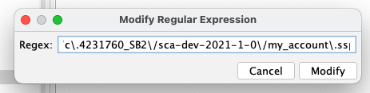
* A good way to check if the regular expression has proper syntax is through a regular expression builder like https://regex101.com/ or https://regexr.com/
- Right click on HUD Context in the Context Sections in the main OWASP ZAP Windows and click on Active Scan

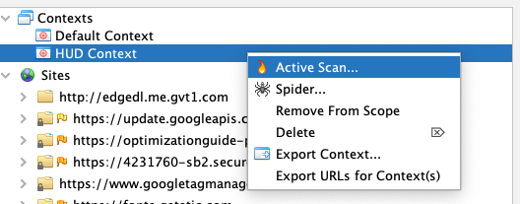
- In the Active Scan Settings Window, keep all default values and click on Start Scan

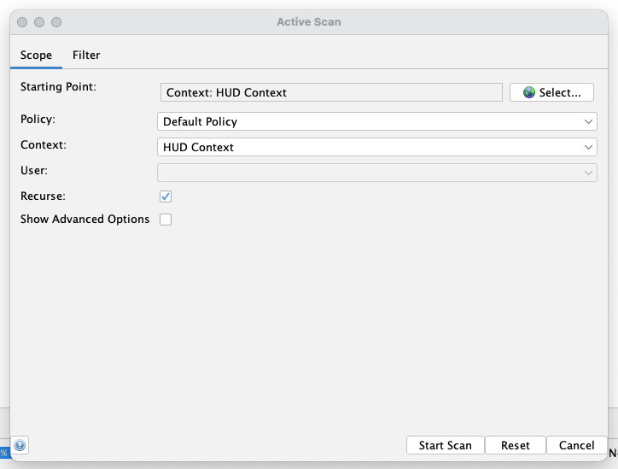

- Wait for the scan to complete its run; any findings will be reflected in the ZAP HUD overlay running on top of the proxied browser

Troubleshooting of OWASP ZAP Windows error:
- Backup your browser preferences (bookmarks, etc.) and export it to a file that can be used later for restoration
- Close all browser instances of Firefox and Chrome; go to Task Manager (Ctrl+Shift+Esc) and terminate all running processes of chrome.exe, firefox.exe, geckodriver.exe, chromedriver.exe)
- After ensuring that no browser instance are active, uninstall OWASP ZAP completely and remove all preference file associated to it (this should be in C:\Users\<your username>\OWASP ZAP; delete this whole folder AFTER uninstalling the program through Windows Control Panel)
- Uninstall Google Chrome completely; download the latest version and reinstall Google Chrome after a machine restart – this should add Google Chrome to the PATH variable of Windows again
- Close Google Chrome and check task manager for all instances of chrome.exe and chromedriver.exe – terminate if you find any of them
- Install OWASP ZAP 2.11.1 again
- Run OWASP ZAP and install Windows WebDrivers from the updates/marketplace pop-up window
- In OWASP ZAP, navigate to Tools > Options > Selenium
- In the Selenium section, under WebDrivers, click on the Bundled button to revert the WebDrivers to the ones that ZAP installed
- The path should be C:\Users\<your username>\OWASP ZAP\webdriver\windows\32\chromedriver.exe and C:\Users\<your username>\OWASP ZAP\webdriver\windows\32\geckodriver.exe
- Run Manual Explore with HUD enabled using Chrome as the preferred browser – the recent installation should be picked up by ZAP
- See if ZAP HUD loads on the proxied instance of Google Chrome

